**Character Name**

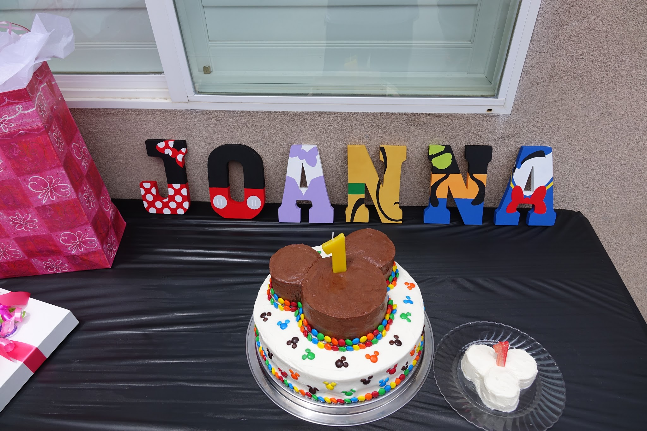

Brighten a child’s special day with their name decorated in the designs of their favorite cartoon characters. The name is designed with each letter in mind and hand-painted. The shape of the letters are shown above, but can vary based on availability. Design requests with specific colors can be made and won’t be created until they meet with your approval. Three-weeks notice is requested (depending on length of name) to design and paint each letter meeting your specifications.